1. 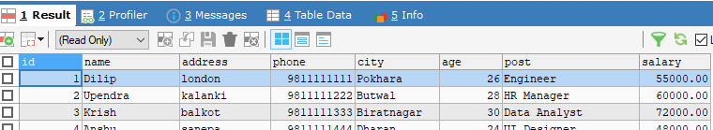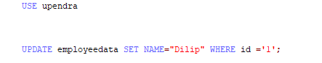Write a SQL query to update data where Id is ‘1’.
2. Write a SQL code to change Address into ‘London’ where name is Dilip.

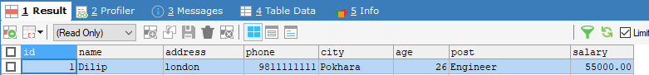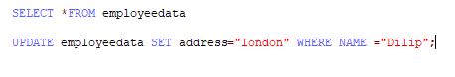

1. 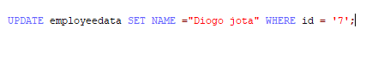Write a SQL code to modify name where Id is 7 .





1. 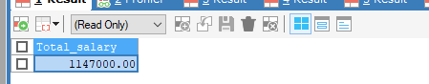Write a SQL code to display records from employee table using aggregation function (SUM, MIN, MAX, AVG, and COUNT).



